Mission Space Lab Phase 4 Report
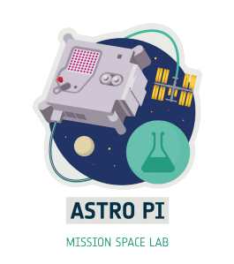

Team name: Centauri
Chosen theme: Life in Space/Life on Earth
Organisation name: Diverbot
Country: Spain

1. Introduction
The climate change that is currently affecting the Earth is mainly due to greenhouse gases. Beyond artificially emitted gases such as CO2, it is well known that water vapor is a major contributor to the greenhouse effect. The highest concentrations of water vapor are found in clouds. It is also known that high clouds affect it to a higher degree than lower clouds.
The objective of our experiment is to find out the height of the clouds and to know if they are in higher or lower areas of the troposphere.
To obtain the data, the new Astro Pi camera was used and then the data was processed on the ground.

2. Method
For the collection of images, the new camera installed in the Astro Pi was used, with which more than 1600 images were taken. In addition, data from all the rest of the sensors was collected in a CSV.
The analysis of the images was performed on Earth. It was decided that the best thing to do was to use an algorithm. The algorithm works as follows: first, the green and blue channels were eliminated, leaving only the red, in addition to decreasing the color levels, so the background remains completely black but the clouds are red (fig.01 and fig.02); then they will select an image and the next one to it; Next, a matrix of 20 x 20 pixels was created and the second image was searched for any other image that approximately coincided with the first one; to continue, the first matrix was moved and compared again, this process is repeated with the entire image (fig.03).
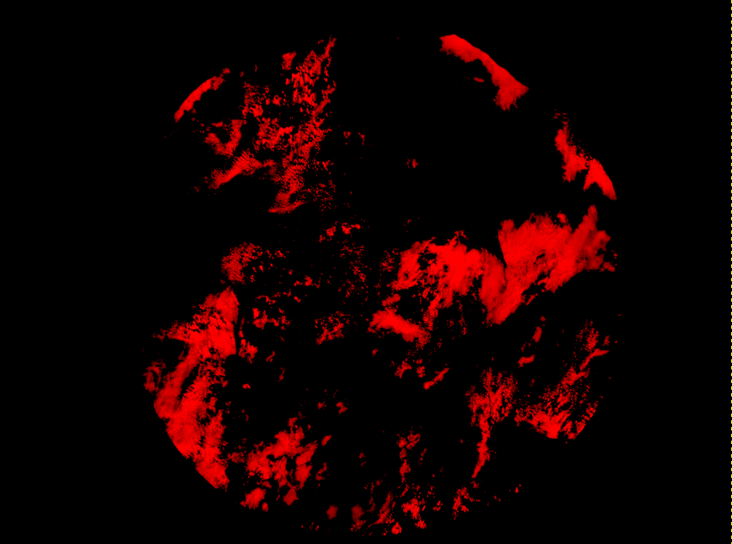Figure 1: An example of fig. 01 converted to red canal only
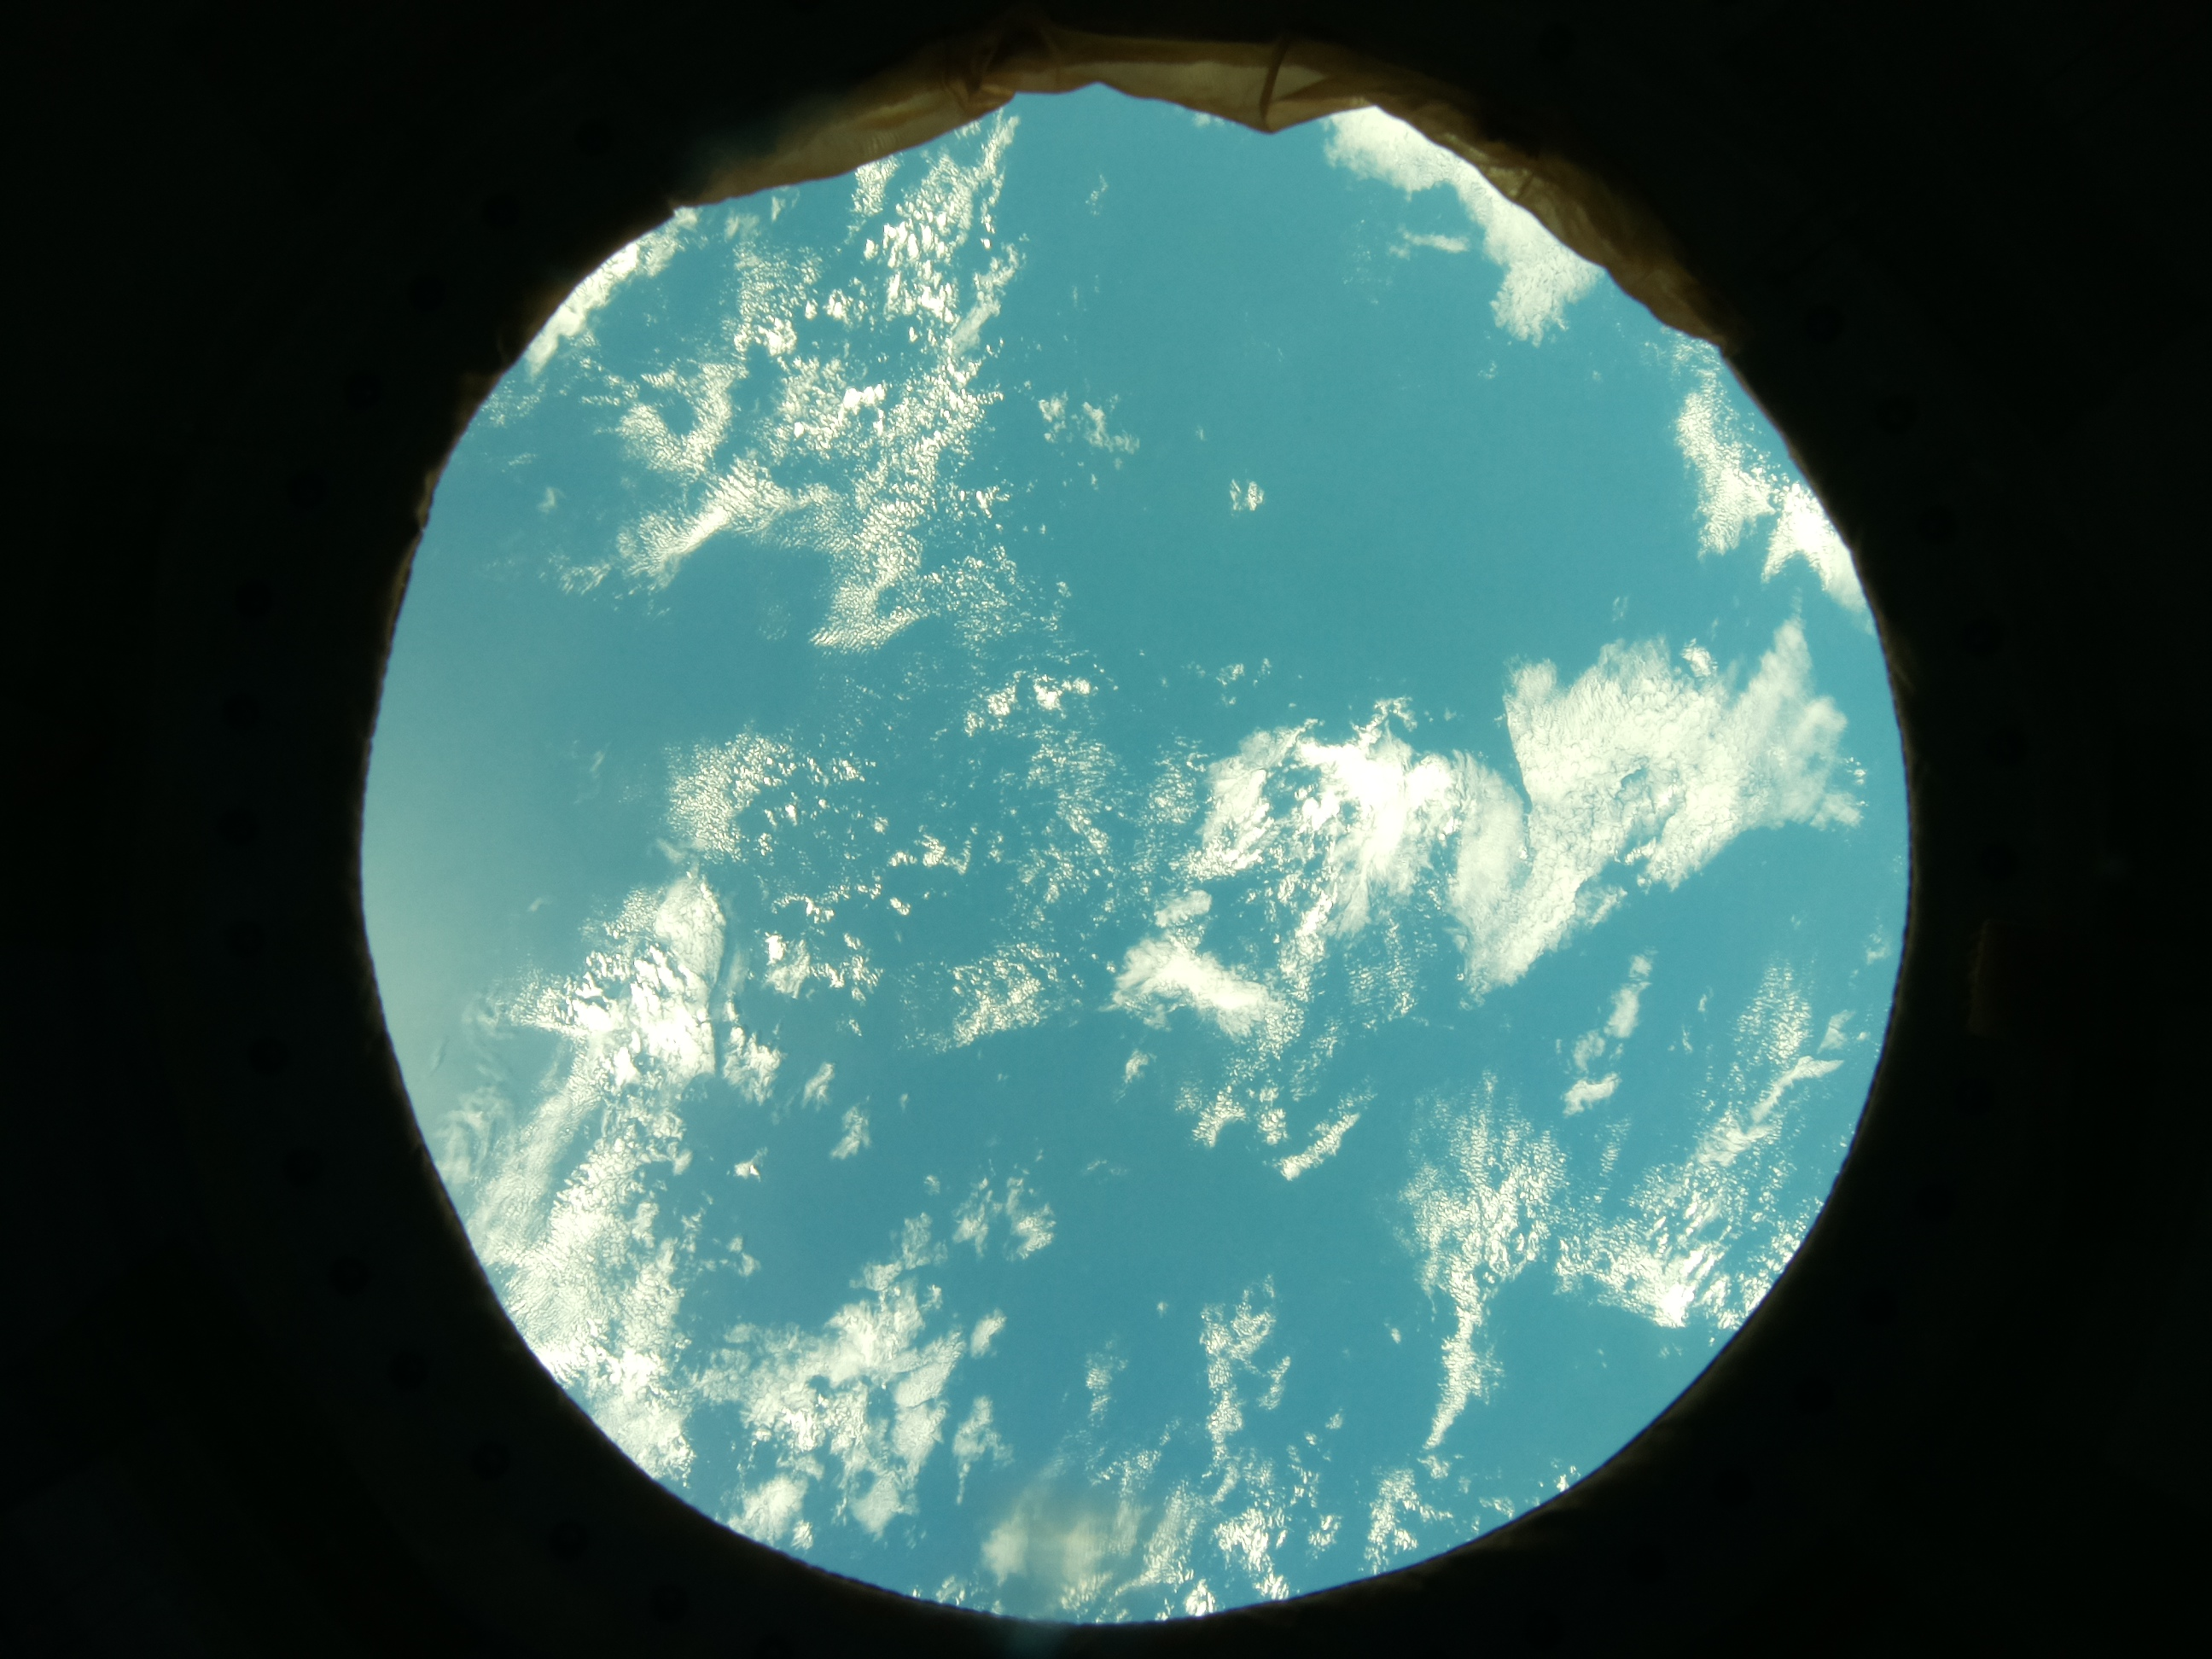Figure 2: An example of an image taken from the Astro Pi camera
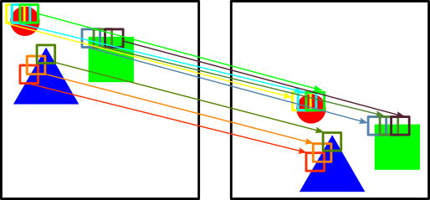Figure 3: A schematic demonstration of how we detect the clouds displacement

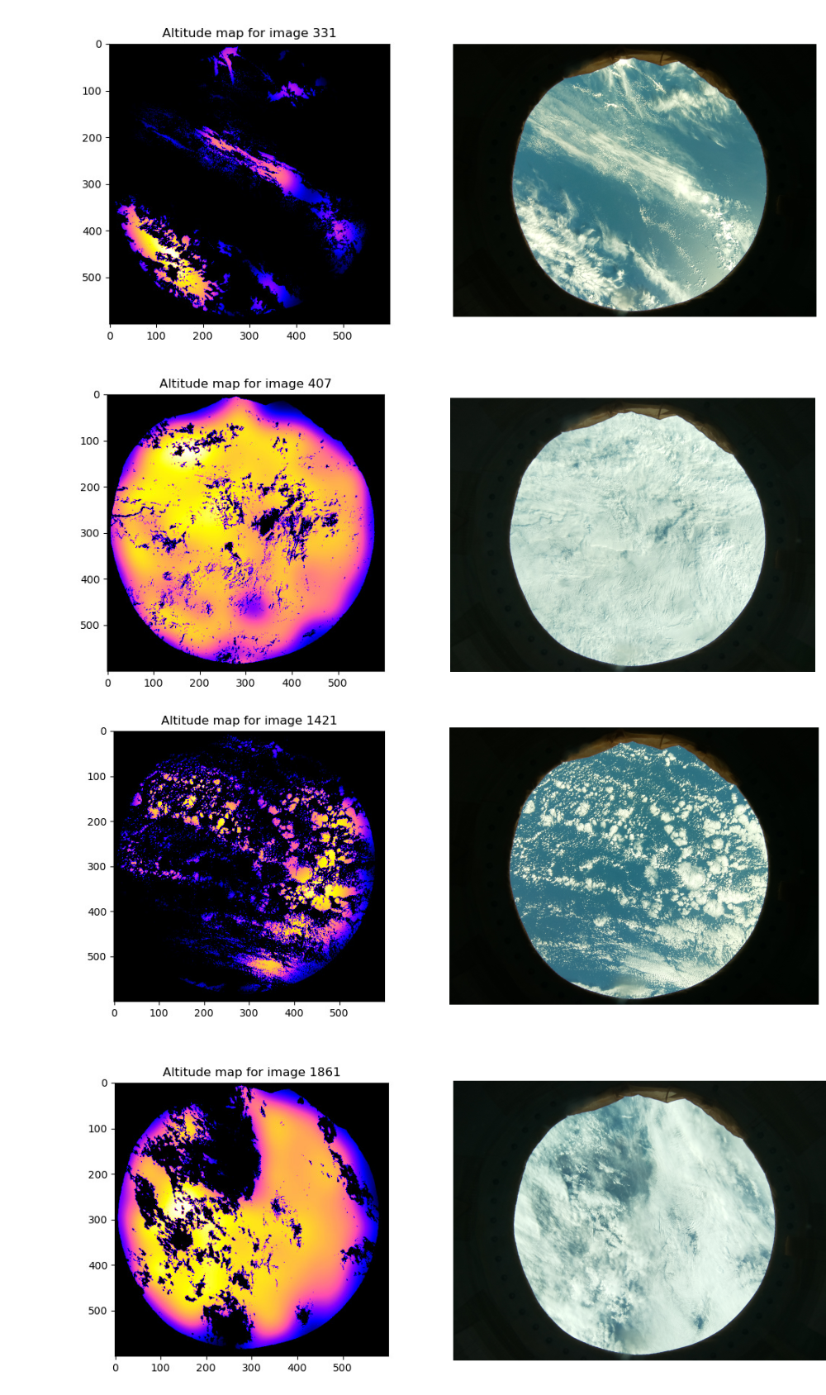Figure 4: Different cloud formations along with their altitude map

3. Experiment results
When capturing the images and processing them by means of the aforementioned method, satisfactory results can be observed (fig.04). To begin, the fact of leaving only the red channel and limiting the colors to leave the background black can be seen that it has worked, since it is not seen as a cloud, which are colored. Then it can be seen that the clouds with less displacement and therefore more low are observed in a more bluish color while the highest ones are observed in a more yellowish color.

4. Learnings
We believe that one of the things that we have all learned alike has been the power of working as a team on jobs of such professionalism. None of the three had ever participated in competitions that required so much professionalism and coordination when writing the code.
One of our great failures is also noteworthy, the lack of coordination of time. We did not coordinate time well with specific time tables, added to the fact that we also signed up for other contests held by the ESA, which meant that we had very little time to analyze the data and work on the project.
We should therefore better coordinate time with the help of platforms like Trello for future projects.

5. Conclusion
As previously mentioned in the third section, the results obtained have been satisfactory and as expected, even better than we expected, because at first we were a bit afraid of having to use an algorithm instead of artificial intelligence. Some changes could be made in the program, especially to make it more efficient because as it is currently being done all the squares of the second image are compared for every one of the first, which results in 348 100 checks for every two images. On the other hand, a program could be programmed that checks only one square per cloud of the first image, which would radically reduce the checks to be carried out. This code was even started to be programmed and even tested, but the lack of time meant that we could not fix its many problems and it was not used.
To conclude, it can be said that the program works, in the absence of some optimization, but it could be scaled to analyze hundreds or thousands of images correctly and thus be able to know the impact of high clouds on global warming.

